Unable to view citation:
BLOT: I believe the JAVAScript is not parsing a title correctly, thus not throwing in a correct variable to allow a citation to be viewed.

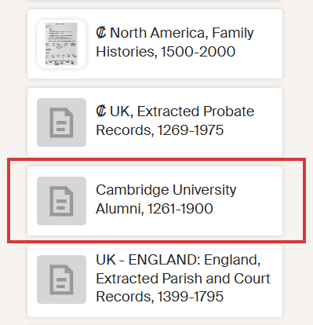 | Choosing to view the Cambridge University Alumni, 1261-1900 source and citation.  Clicking on the view button gives me an error.  The error given to me is a Cannot read properties of undefined (reading 'mode'). error. Google search confirms my suspicion of null input.  Noticed in the error message a link to "Fell.-Com. "

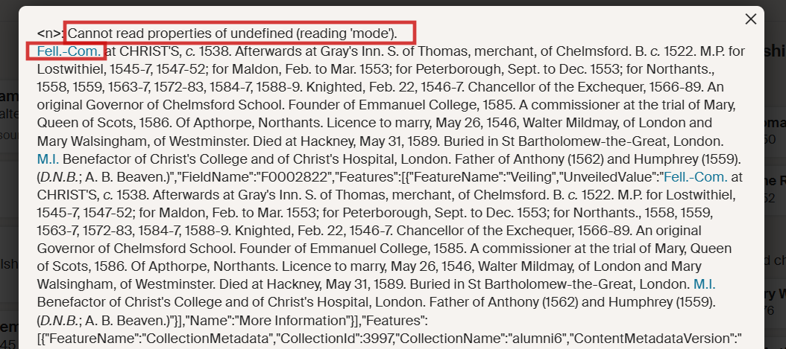

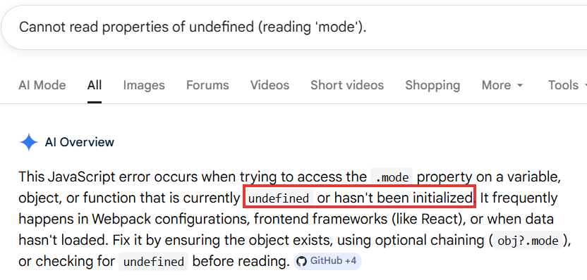
Clicked on the "Fell.-Com. " link. Link goes to https://www.ancestry.com/%22javascript:APop(p1,130,156);/%22 That link throws am Error 21.
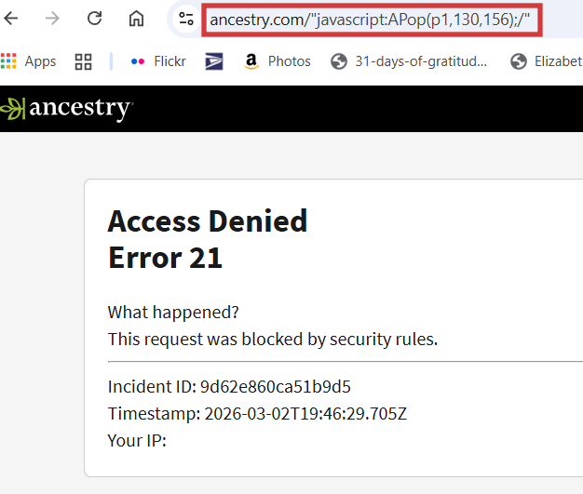

A Google search of "Fell.-Com. at CHRIST'S" pulled up a link to https://archive.org/stream/p1alumnicantabri02univuoft/p1alumnicantabri02univuoft_djvu.txt
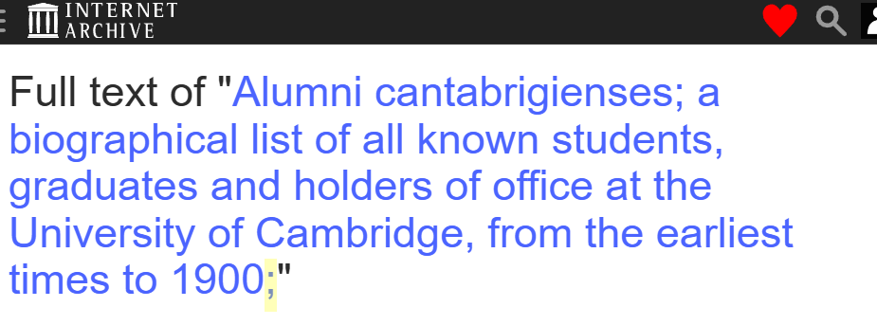
Highlighted is a semi-colon. This could be the root of the issue if the semi-colon is coded into the title.

